Title of the Article in English
(Concise but informative. A maximum of two lines are accepted, a maximum of 100 characters with spaces).

Abstract

The length of the abstract should not exceed 200 words, where the reason and objective of the research, the methodology used, the most outstanding results and the main conclusions are concisely described. It must be written in an impersonal way: «This work is analyzed ...». The text will be in Arial 10 single line spacing, full justified.

Keywords

Between 4 and 6 keywords should be selected. The use of these descriptors and the UNESCO Thesaurus is recommended. Only in exceptional cases are new terms accepted.

Resumen

La extensión del resumen estará no deberá sobrepasar las 200 palabras, donde se describe de forma concisa el motivo y el objetivo de la investigación, la metodología empleada, los resultados más destacados y principales conclusiones. Ha de estar escrito de manera impersonal: «El presente trabajo se analiza…». El texto estará en Arial 10 interlineado simple, justificado completo. For its preparation, as for the title and keywords, the quality of the linguistic level and style will have to be guaranteed, which our reviewers will take into account as part of the evaluation of the manuscript.

Palabras Clave

Se deberán seleccionar entre 4 y 6 palabras clave. Se recomienda el uso de estos descriptores y del Thesaurus de la UNESCO.

Introduction (Arial 14, bold, each word starting with a capital letter)

It should include the fundamentals and purpose of the study, emphasizing the relevance of the theoretical and practical object, using bibliographic citations. The structure of the article can be considered if it is considered pertinent. The text will be in Arial 11, single spacing, full justified. The total length of the manuscript should not exceed 10,000 words, including references, tables and appendices.

Literature Review

A more significant review of the theoretical and methodological framework of the subject should be carried out at the national and international level. In some types of articles, such as case studies, this content could be linked to the introduction. Paragraphs must be separated by a single space. And the sections must be separated by two single spaces.

Material and Methods

It will be presented with the precision that is convenient for the reader to understand and confirm the development of the research. Where appropriate, the sample and the sampling strategies will be described, as well as the type of statistical analysis used. If it is an original methodology, it is necessary to state the reasons that have led to its use and describe its possible limitations. Two more levels can be used for subtitles, as follows:

Sample Determination (Arial 11, bold, each word starting with a capital letter)

Workers (Arial 11, bold, italics, each word starting with a capital letter)

Analysis and Results

An attempt will be made to highlight the most important observations, describing, without making value judgments, the material and methods used, as well as the most relevant results of the investigation. The results will be presented in figures and (or) tables according to the rules of the journal. They will appear in a logical sequence in the text, tables or essential figures, avoiding data redundancy.

Tables must be presented incorporated in the text in Word according to the order of appearance, numbered in Arabic. A Table must be referenced in the text at least once and before the Table appears. For example, Table 1 that is included in this document. A summary of the contents of the table and an explanation of its organization and interpretation must be provided. As far as possible, the table layout should use only horizontal parting lines.

Table 1
Table example.
Column header | Column header | Column header
Text | 45 | 753
Text | 45 | 753
Text | 45 | 753
Text | 78 | 258
Text | 159 | 75
Note: Include table notes only as necessary.

The table must not include a title in it. The table title should be placed above the table and on the same page, never on the next page. The table title should use the following style:

Font: Arial 10, normal.
Alignment: left.
Front spacing 0 points and rear 6 points.
Line spacing: single.

Figures can be photographs, illustrations, images, etc. It is recommended to work with images with the highest possible resolution in PNG format and with separate files in editable (modifiable) format. Figures must be mentioned and referenced in the text at least once and before they appear.

The number of figures and tables will not exceed ten between the two, although it will be assessed as required and the contribution of the information to the quality of the manuscript. They will be presented incorporated in the text, according to their order of appearance, numbered in Arabic and titled with an abbreviated description of their content. The figure must not include a title in it and must be referenced in the text; example, as shown in Figure 1.

Figure 1
Example of a figure title.
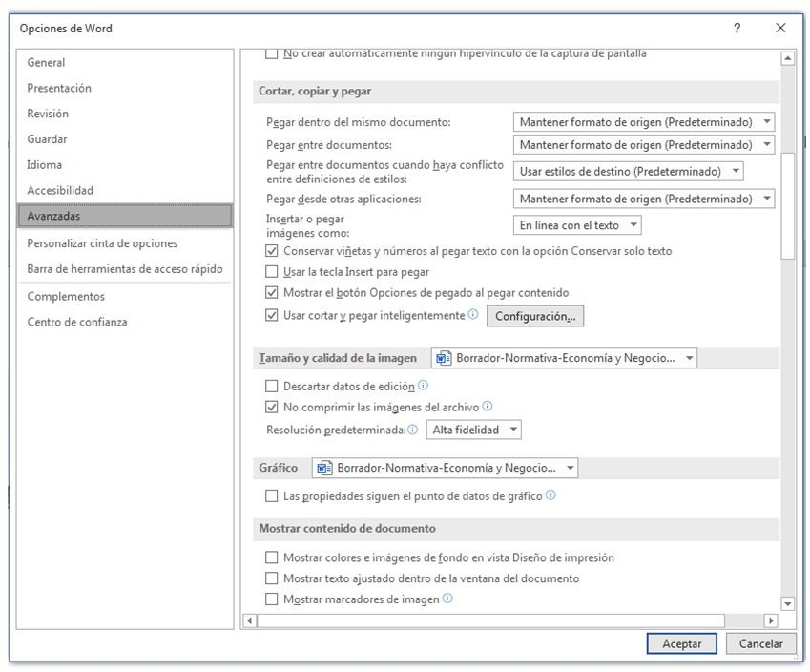
Note: Include figure notes only as necessary.

The title of a figure should be placed above the figure and on the same page. The title of a figure should use the following style:

Font: Arial 10, normal.
Alignment: left.
Front spacing 0 points and rear 6 points.
Line spacing: single.

The width of a shape should never encroach on the margins of the page and should not be between two pages. A table or text box should not be treated as a figure.

The equations must be created using an equation editor. You should avoid inserting equations as images. Equations must be mentioned and referenced in the text at least once and before the equation appears. The equations must be written centered and identified with the title "Equation n", as seen in Equation 1.

Equation 1
$$PE=\frac{Cf}{Py-Cv}$$

The title of an equation should be located above the table and on the same page. The symbols in an equation must be defined before or immediately after they appear in the equation.
Abbreviations Only universally accepted ones should be used. (See: Units Symbols and Abbreviations). When trying to shorten a term frequently used in the text, the corresponding abbreviation, in parentheses, must be accompanied the first time it appears. Roman numerals will not be used in the text, using the point to the right of zero for decimals and not the comma (for the Spanish version). Complementary material. When it is required to supplement the manuscript with complementary documents and materials (visual, audiovisual, statistical annexes, extensive tables, complex graphics, etc.) that cannot be inserted in the articles due to format and size, these documents may be published in a digital repository that offer a complementary DOI.

Discussion and Conclusions

It will summarize the findings, relating the observations themselves with other studies of interest, pointing out contributions and limitations, without reiterating data already discussed in other sections. The inferences of the findings and their limitations should be mentioned, including the deductions for future research, as well as linking the conclusions with the objectives of the study, avoiding gratuitous statements and conclusions not fully supported by the data of the work.

Acknowledgments

All contributors who do not meet the authorship criteria should be listed in an Acknowledgments section. Examples of people who might be recognized include a person who provided purely technical help, or a department head who only provided general support. Please provide any personal acknowledgments separate from the main text to facilitate anonymous peer review.

In addition, individuals who provided writing assistance, part of a communications firm, do not qualify as authors and should therefore be listed in the Acknowledgments section. Authors must disclose any writing assistance, including the name of the person, company, and level of contribution, and identify the entity that paid for this assistance. It is not necessary to disclose the use of language polishing services.

Financing

Economy and Business requires all authors to consistently acknowledge their funding under a separate heading. The funding agency must be written in full, followed by the grant number in square brackets, see the example below:

“This work was supported by the Economic Research Council [grant number xxx].”

Multiple grant numbers must be separated by commas and spaces. When the research was supported by more than one agency, the different agencies should be separated by semicolons, with 'and' preceding the final funder. Thus:

“This work was supported by the Trust [grant numbers xxxx, yyyy]; Natural Environment Research Council [grant number zzzz]; and the Council for Economic and Social Research [grant number yyyy].”

In some cases, research is funded not by a specific project grant, but by the block grant and other resources available to a university, college, or other research institution. Where no specific research funding has been provided, we ask corresponding authors to use the following sentence:

“This research did not receive a specific grant from any funding agency in the public, commercial, or nonprofit sectors.”

Conflict of Interest Statement

Economía y Negocios encourages authors to include a declaration of any conflict of interest at the end of their manuscript, after acknowledgments and before references. We recommend reviewing our best practice guidelines. If there is no conflict, indicate that "The author(s) declare(s) that they have no potential conflicts of interest with respect to the research, authorship and/or publication of this article.".

Statement of Ethical Approval or Informed Consent

The authors must write a statement on the ethical approval of the use of the data used in the research. An example might be: “All information extracted from the study will be encrypted to protect the name of each subject. No names or other identifying information will be used when discussing or reporting data. All subjects gave their informed consent for inclusion before participating in the study. The investigators will securely keep all collected files and data in a locked cabinet in the principal investigators' office.”

References

Bibliographic citations should be reviewed in the form of references to the text. Uncited bibliography should not be included in the text. The number of citations will be between 20 and 60, it must be sufficient and necessary to contextualize the theoretical framework, the methodology used and the research results in an international research space. They will be presented alphabetically by the author's first surname (adding the second only in case the first is very commonly used, and joined with a hyphen). The citations must be extracted from the original documents - preferably journals and, to a lesser extent, books - always indicating the initial and final page of the work from which they come, with the exception of complete works.

Given the importance for the citation indexes and the calculations of the impact factors, the correct citation will be assessed in accordance with the APA 7.0 Standard, valuing the fact that there are not only national references, but also prestigious international journals.

Standards for References

Bibliographic references will be cited according to APA standards, seventh edition. Here are examples of bibliographic references:

Magazine Articles:
Schaefer, N.K., & Shapiro, B. (2019, September 6). New middle chapter in the story of human evolution. Science, 365(6457), 981–982. https://doi.org/10.1126/science.aay3550
Schulman, M. (2019, September 9). Superfans: A love story. The New Yorker. https://www.newyorker.com/magazine/2019/09/16/superfans-a-love-story

- Quotes in parentheses: (Schaefer & Shapiro, 2019; Schulman, 2019)
  - Narrative quotes: Schaefer y Shapiro (2019) y Schulman (2019)

Articles in Scientific Journals:
Ruiz-de la Peña, J., Pérez-Campdesuñer, R., & Andrade-Molina, P.G. (2022). Production Management from Intelligent Models for Industry 4.0: Challenges and Opportunities. Economía y Negocios, 13(2), 1–15. https://doi.org/10.29019/eyn.v13i2.1084
Basantes-Garcés, P., Romero-Larco, G., Chávez-Puga, O., & Cadena-Villegas, E. (2019). The Authorized Economic Operator in the Andean Community Countries, as a Security Standard in the Logistics Chain of Goods. Economía y Negocios, 10(2), 106–123. https://doi.org/10.29019/eyn.v10i2.623
Aguaded, I. (2014). Research as a training strategy for educommunicators: Master's and Doctorate. Comunicar, 43, 7-8. https://doi.org/10.3916/C43-2014-a1

- Quotes in parentheses: (Ruiz-de la Peña et al., 2022; Basantes-Garcés et al., 2019; Aquaded, 2014)
  - Narrative quotes: Ruiz-de la Peña et al. (2022), Basantes-Garcés et al. (2019) y Aquaded (2014)

Newspaper Article:
Carreño, L. (2020, February 9). La disputa gremial por los aranceles a las prendas de vestir. El Espectador. https://bit.ly/3JhNyIg
Carey, B. (2019, March 22). Can we get better at forgetting? The New York Times. https://www.nytimes.com/2019/03/22/health/memory-forgetting-psychology.html

Books:
Herrera Cáceres, C., & Rosillo Peña, M. (2019). Confort y eficiencia energética en el diseño de edificaciones. Universidad del Valle.
Asquer, A., Becchis, F., & Russolillo, D. (2016). The political economy of local regulation: theoretical frameworks and international case studies (1ra ed.). Palgrave Macmillan.

Chapter of the Book:
Krugman, P., Obstfeld, M., & Melitz, M. (2019). Política comercial internacional. In A. Cañizal (Ed.), Economía internacional (9th ed., pp. 195-279). Pearson.
Note: In case the books have DOI, it must be included after the publisher.

Theses or Dissertations:
Martínez Ribón, J.G.T. (2011). Propuesta de metodología para la implementación de la filosofía Lean (construcción esbelta) en proyectos de construcción [Master's Thesis, Universidad Nacional de Colombia]. https://bit.ly/43MzLld
Varga Pérez, J.A. (2018). Detección y prevención de virus respiratorios aplicado a plásticos burbujas [Unpublished doctoral thesis]. Universidad Católica.

Websites:
United Nations Educational, Scientific and Cultural Organization. (2023, April 12). Promoting Cultural Heritage Integration in Ocean Conservation Initiatives and Marine Protected Areas: Caribbean and Central Americas States Call to Action. UNESCO. https://bit.ly/3D74GwZ
Department of Economic and Social Affairs Economic Analysis. (2020, October 5). World Economic Situation and Prospects 2020: Executive Summary. United Nations. https://bit.ly/2WSEjp3

Seminars, Congresses, Symposiums or Conferences:
Sánchez, C., Ayala, D., & Bocarosa, E. (2018, November 17-29). Biodiversity and human survival on earth [Main speech]. V United Nations Conference, Sharm, El-Sheikh, Egipto.
Masiero, S. (2015, July 7–10). Teoría de la evaluación de la conexión neurosocial [Conference presentation summary]. Segunda convención de la Asociación Argentina de Alternativas en Psicología, Buenos Aires, Argentina. https://url.org/resumen.pdf

It is prescriptive that all citations that have DOI (Digital Object Identifier System) are reflected in the References (they can be obtained at https://search.crossref.org/). All journals and books that do not have DOI must appear with their link (in their online version, if they have it, shortened). All the web addresses that are presented have to be shortened in the manuscript through https://bitly.com/, with the exception of the DOI that must be in the indicated format.

Economía y Negocios has a bibliographic collection of published articles. A review of this literature is recommended, prioritizing scientific works with great international diffusion. However, the saturation of citations of the authors and of this journal (self-citations) should be limited and carefully controlled. National and international journals indexed in the Journal Citation Reports (JCR), Scopus, WOS, REDIB, Dialnet Metrics, ERIH and FECYT are recommended. In relation to the number of citations, it will depend on the nature of the work (focus and scope).

